Busselton Senior High School

Semester One Examination, 2017

Question/Answer booklet

MATHEMATICS

SOLUTIONS
METHODS
UNIT 3

Section One:

Calculator-free

Student Number: In figures

In words

Your name

Time allowed for this section
Reading time before commencing work: five minutes
Working time: fifty minutes

Materials required/recommended for this section
To be provided by the supervisor
This Question/Answer booklet
Formula sheet

To be provided by the candidate
Standard items: pens (blue/black preferred), pencils (including coloured), sharpener, correction fluid/tape, eraser, ruler, highlighters

Special items: nil

Important note to candidates
No other items may be taken into the examination room. It is your responsibility to ensure that you do not have any unauthorised material. If you have any unauthorised material with you, hand it to the supervisor before reading any further.

Structure of this paper

Section | Number of questions available | Number of questions to be answered | Working  time (minutes) | Marks available | Percentage of examination
Section One:  Calculator-free | 8 | 8 | 50 | 52 | 35
Section Two:  Calculator-assumed | 11 | 11 | 100 | 98 | 65
 |  |  |  | Total | 100

Instructions to candidates

1. The rules for the conduct of examinations are detailed in the school handbook. Sitting this examination implies that you agree to abide by these rules.

2. Write your answers in this Question/Answer booklet.

3. You must be careful to confine your response to the specific question asked and to follow any instructions that are specified to a particular question.

4. Additional working space pages at the end of this Question/Answer booklet are for planning or continuing an answer. If you use these pages, indicate at the original answer, the page number it is planned/continued on and write the question number being planned/continued on the additional working space page.

5. Show all your working clearly. Your working should be in sufficient detail to allow your answers to be checked readily and for marks to be awarded for reasoning. Incorrect answers given without supporting reasoning cannot be allocated any marks. For any question or part question worth more than two marks, valid working or justification is required to receive full marks. If you repeat any question, ensure that you cancel the answer you do not wish to have marked.

6. It is recommended that you do not use pencil, except in diagrams.

7. The Formula sheet is not to be handed in with your Question/Answer booklet.

Section One: Calculator-free 35% (52 Marks)
This section has eight (8) questions. Answer all questions. Write your answers in the spaces provided.

Working time: 50 minutes.

Question 1 (5 marks)
The graph below shows the curve $y=$ $\frac{180}{{(2x+5)}^{2}}$ and the line $x=5$.

Determine the area of the shaded region, enclosed by the $x-$ axis, the $y-$ axis, the line $x=5$ and the curve.

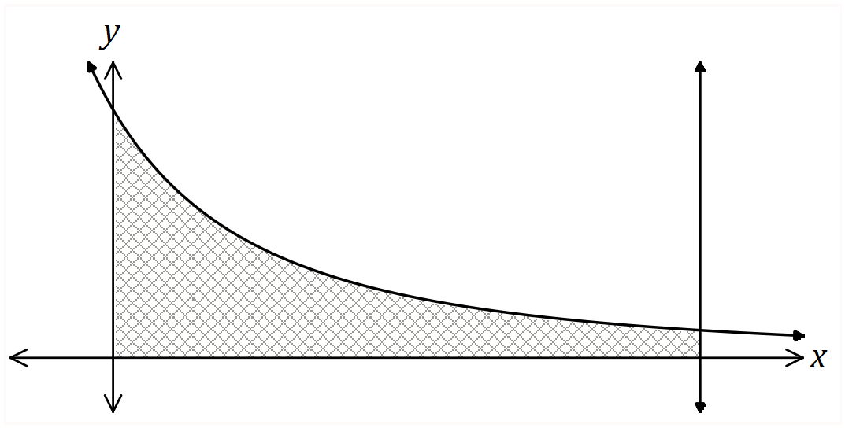

Solution
$A=\int_{0}^{5}{}{180(2x+5)}^{-2}dx={[{-\frac{180}{2}×(2x+5)}^{-1}]}_{0}^{5}=-90[\frac{1}{15}-\frac{1}{5}]=-90×\frac{-2}{15}=12 sq units$

Specific behaviours
✓ writes integral
✓ antidifferentiates - correct power
✓ antidifferentiates - correct multipliers
✓ substitutes bounds
✓ simplifies

Question 2 (8 marks)
A small body, initially at the origin, moves in a straight line with acceleration $a(t)=6t-10$ ms⁻², where $t$ is the time in seconds, $t≥0$. When $t=5$, it was observed to have a velocity of 31 ms⁻¹.

(a) Determine an expression for $v(t)$, the velocity of the body. (2 marks)

Solution
$v(t)=3t^{2}-10t+c$
$31=75-50+c⇒c=6$
$v(t)=3t^{2}-10t+6$

Specific behaviours
✓ antidifferentiates
✓ evaluates constant and states expression

(b) Determine the acceleration of the body when $v=19$. (3 marks)

Solution
$3t^{2}-10t+6=19{3t}^{2}-10t-13=0(3t-13)(t+1)=0t=-1, t=\frac{13}{3}$
$a=6×\frac{13}{3}-10=16 {m/s}^{2}$

Specific behaviours
✓ uses $v=19$ to obtain quadratic equal to zero
✓ solves quadratic for $t$ ($+ve$ only)
✓ determines $a$

(c) Determine the velocity of the body as it passes through the origin for the last time.
(3 marks)

Solution
$x(t)=t^{3}-5t^{2}+6t$
$0=t(t-2)(t-3)$
$t=3$
$v(3)=27-30+6=3 m/s$

Specific behaviours
✓ antidifferentiates to obtain displacement equation
✓ solves for last $t$
✓ determines $v$

Question 3 (6 marks)
The graph of $y=f(x)$ is shown below, where $f(x)=e^{x}(x^{2}-3)$.

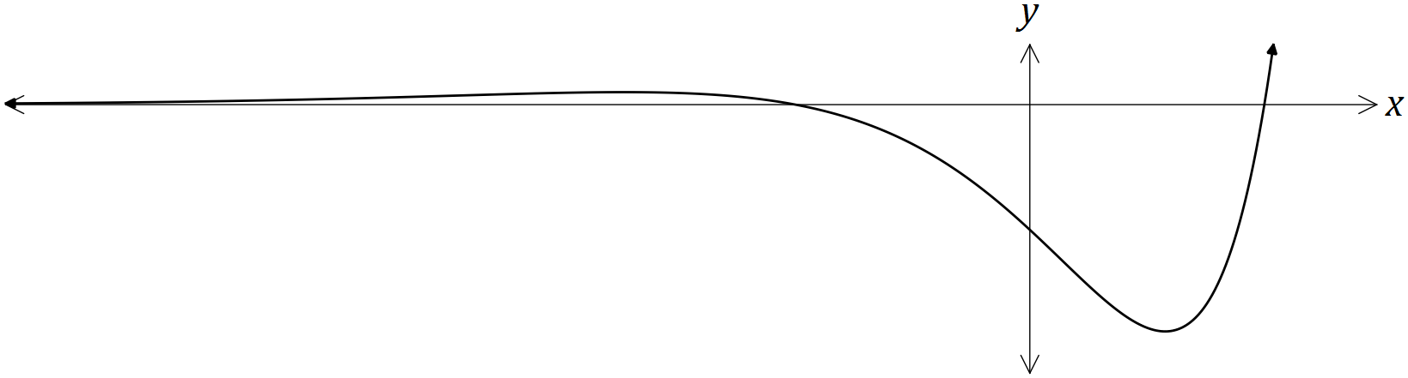

(a) Show that $f^{'}(x)=e^{x}(x^{2}+2x-3)$. (1 mark)

Solution
$f^{'}(x)=e^{x}(x^{2}-3)+e^{x}(2x)=e^{x}(x^{2}+2x-3)$

Specific behaviours
✓ indicates use of product rule

(b) Determine the $x-$ coordinates of the stationary points of $f(x)$. (2 marks)

Solution
$e^{x}(x^{2}+2x-3)=0(x+3)(x-1)=0x=-3, 1$

Specific behaviours
✓ factorises
✓ states $x-$ values

(c) Given that $f^{''}(x)=e^{x}(x^{2}+4x-1)$, use the second derivative to justify that one of the stationary points is a local minimum and that the other is a local maximum. (3 marks)

Solution
$f^{''}(-3)=9-12-1=-4⇒Local maximum when x=-3$

$f^{''}(1)=1+4-1=4⇒Local minimum when x=1$

Specific behaviours
✓ clearly shows $f^{''}(-3)$ is $-ve$
✓ clearly shows $f^{''}(1)$ is $+ve$
✓ interprets signs of second derivative as required

Question 4 (8 marks)
(a) Determine $\frac{d}{dx}(\frac{1+e^{2x}}{1+\sqrt{x}})$. (3 marks)

Solution
$\frac{d}{dx}(\frac{1+e^{2x}}{1+\sqrt{x}})=\frac{{2e}^{2x}(1+\sqrt{x})-(1+e^{2x})(\frac{1}{2\sqrt{x}})}{{(1+\sqrt{x})}^{2}}$

Specific behaviours
✓ obtains $u'v$
✓ obtains $uv^{'}$
✓ uses correct form of quotient rule
(simplification not required)

(b) Determine $\frac{d}{dx}$ $(2xsin (3x) )$. (2 marks)

Solution
$\frac{d}{dx}(2xsin (3x) )=2sin (3x) +2x∙3∙cos (3x) =2sin (3x) +6xcos (3x)$

Specific behaviours
✓ applies product rule
✓ differentiates correctly
(simplification not required)

(c) Use your answer from (b) to determine $\int{}6xcos (3x) dx$. (3 marks)

Solution
$\int{}6xcos (3x) dx=\int{}2sin (3x) +6xcos (3x) -2sin (3x) dx=\int{}2sin (3x) +6xcos (3x) dx-\int{}2sin (3x) dx=2xsin (3x) +\frac{2}{3}cos (3x) +c$

Specific behaviours
✓ uses linearity of anti-differentiation
✓ integrates using reverse differentiation
✓ obtains expression, including constant

Question 5 (6 marks)
The table below shows the probability distribution for a random variable $X$.

It is known that $E(X)=1.7$ and $Var(X)=1.41$.

$x$ | $0$ | $1$ | $2$ | $3$
$P(X=x)$ | $a$ | $a+b$ | $b$ | $2a$

(a) Determine the values of the constants $a$ and $b$. (4 marks)

Solution
$4a+2b=1$
$0(a)+1(a+b)+2(b)+3(2a)=1.7$

$7a+3b=1.7$
$6a+3b=1.5$

$a=0.2, b=0.1$

Specific behaviours
✓ equation using sum of probabilities
✓ equation using expected value
✓ determines $a$
✓ determines $b$

(b) Determine

(i) $E(3-2X)$. (1 mark)

Solution
$3-2(1.7)=-0.4$

Specific behaviours
✓ states value

(ii) $Var(3-2X)$. (1 mark)

Solution
${(-2)}^{2}(1.41)=5.64$

Specific behaviours
✓ states value

Question 6 (7 marks)
(a) The function $f$ is such that $f(1)=-2$ and $f^{'}(x)=\sqrt{3+x^{2}}$. Use the increments formula to determine an approximate value for $f(1.05)$. (3 marks)

Solution
$y=f(x)⇒δy≈f^{'}(x)δx$

$x=1, δx=0.05$

$δy≈\sqrt{3+1^{2}}×0.05≈0.1$

$f(1.05)≈-2+0.1≈-1.9$

Specific behaviours
✓ identifies values of $x$ and $δx$
✓ uses formula to calculate increment
✓ calculates approximation

(b) The function $C$ is such that $C(1)=10$ and $C^{'}(x)=3\sqrt{x+3}$.

(i) Explain why the increments formula would not yield an approximate value for $C(6)$.

Solution
The increment in $x$ from 1 to 6 is not small.

Specific behaviours
✓ reason
(1 mark)

(ii) Determine $C(6)$. (3 marks)

Solution
$∆C=\int_{1}^{6}{}3\sqrt{x+3}dx=\int_{1}^{6}{}3{(x+3)}^{\frac{1}{2}}dx={[2{(x+3)}^{\frac{3}{2}}]}_{1}^{6}=54-16=38$

$C(6)=C(1)+∆C=10+38=48$

Specific behaviours
✓ antidifferentiates
✓ evaluates total change
✓ correct value

Question 7 (6 marks)
A rectangle has its base on the $x-$ axis, its lower left corner at $(0, 0)$ and its upper right corner on the curve shown below, $y=cos 2x$, $0≤x≤\frac{π}{4}$.

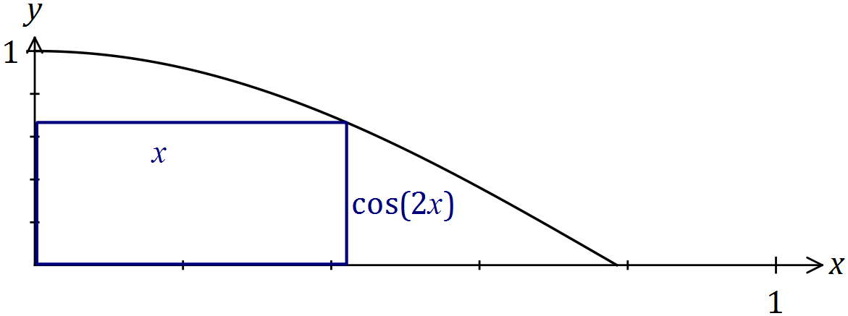

(a) Sketch a possible rectangle on the graph above and explain why the perimeter of the rectangle is given by the function $p(x)=2x+2cos 2x$. (2 marks)

Solution
See diagram.
Perimeter is twice base ($2x)$ plus twice height ($2cos 2x$).

Specific behaviours
✓ rectangle as required
✓ explanation using diagram

(b) Determine the largest perimeter of the rectangle. (4 marks)

Solution
$p^{'}(x)=2-4sin 2x p^{'}(x)=0 whensin 2x =\frac{1}{2}x=\frac{π}{12}p(\frac{π}{12})=\frac{π}{6}+2cos \frac{π}{6} =\frac{π}{6}+\sqrt{3}$

Specific behaviours
✓ derivative
✓ equates to zero and obtains trig equation
✓ solves for $x$ within domain
✓ determines $p_{MAX}$

Question 8 (6 marks)
The graph of $y=f(t)$ is shown below over the interval $0≤t≤10$.

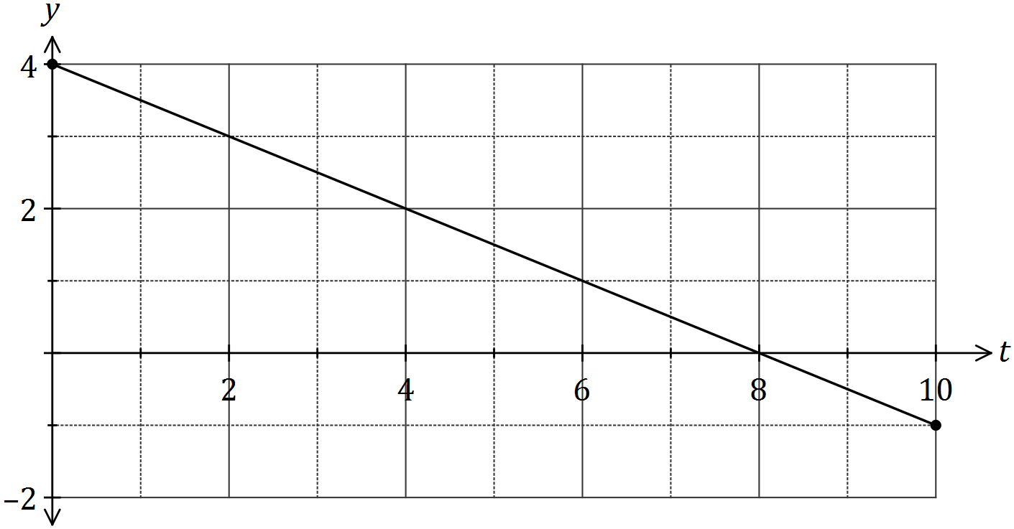

(a) Use the graph to determine an estimate for $\int_{0}^{2}{}f(t)dt$. (2 marks)

Solution
$\int_{0}^{2}{}f(t)dt=Area=\frac{4+3}{2}×2=7$

Specific behaviours
✓ indicates area calculation
✓ correct estimate

(b) On the axes below, sketch the graph of $y=F(x)$ for $0≤x≤10$, where $F(x)=\int_{0}^{x}{}f(t)dt$.
(4 marks)

Solution
See graph
Specific behaviours
✓ starts at (0, 0) and includes (2, 7) from (a)
✓ maximum at (8, 16)
✓ endpoint close to (10, 15)
✓ smooth parabolic shape
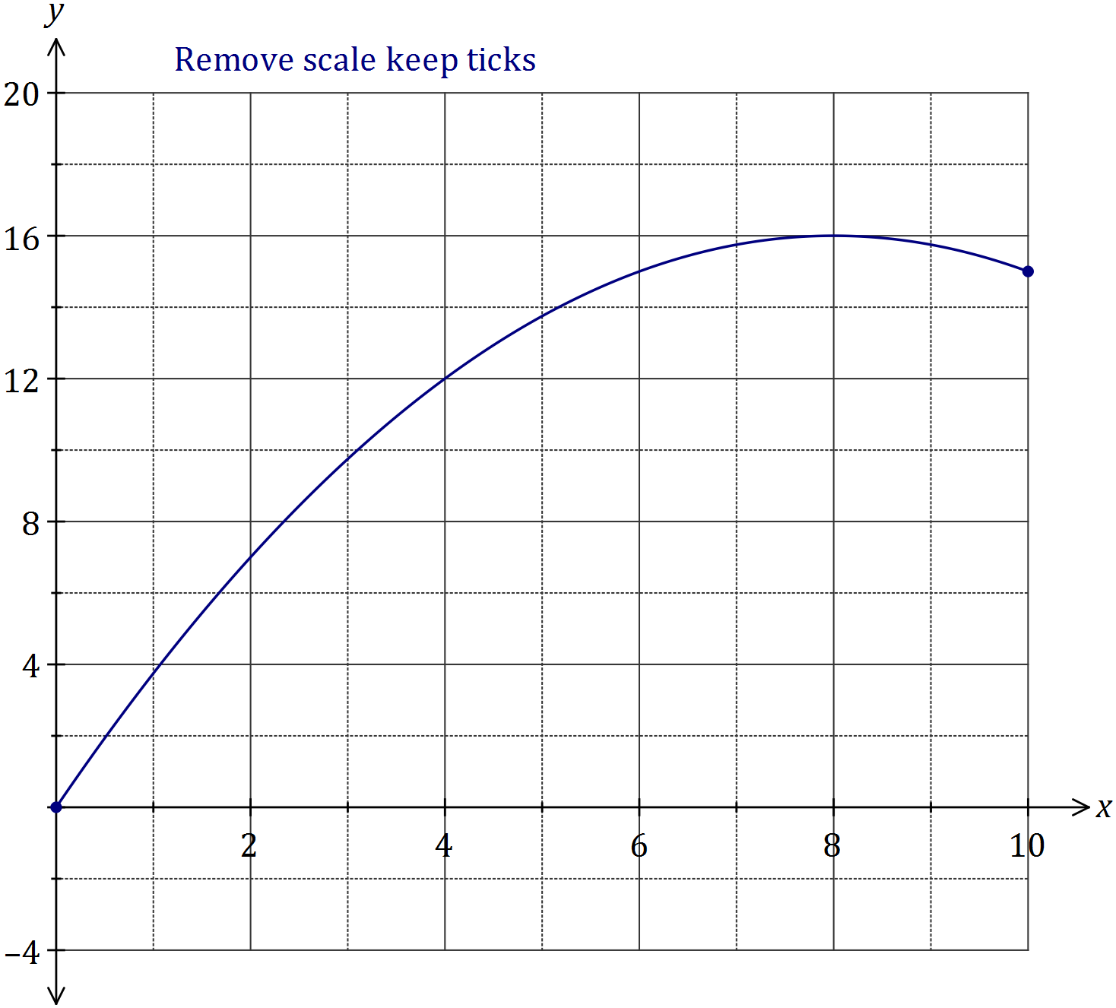

Additional working space

Question number: _________

© 2016 WA Exam Papers. Busselton Senior High School has a non-exclusive licence to copy and communicate this paper for non-commercial, educational use within the school. No other copying, communication or use is permitted without the express written permission of WA Exam Papers. SN177-095-2.

